

**CZ4042 Project Report**

Members:

Ng Chen Ee Kenneth (U1721316F)

Goh Yong Wei (U1722195H)

Ngo Jun Hao Jason (U1721978B)

Table of Contents

**Project Objective** **2**

**Overview** **3**

**Data Exploration** **4**

CelebA 4

Dataset Description 4

Adience 5

Dataset Description 5

Choice of Dataset 6

Changes to the Dataset 6

**Data Preprocessing** **6**

Adience 6

CelebA 7

**Modelling** **7**

Starting Simple 8

Understanding Limitations 9

**Selecting Model Architecture** **10**

Hassner CNN 10

ResNet50 12

MobileNetV2 13

Comparison Of Model Architectures 16

**Data Augmentation** **17**

Sample image from dataset 17

Horizontal Flip 17

Image Rotation 18

Adjusting Brightness 18

Results 19

**Hyperparameter Tuning** **20**

Optimal Batch Size, Neurons and Learning Rate 20

Optimal Decay Rate 22

Optimal No. of Dropouts 23

**Pre-training** **24**

Experiments Before Tuning 25

Experiments After Tuning 28

Without pretraining 28

After Pretraining 29

**Evaluation of Results** **31**

**Future Considerations** **31**

**Conclusion** **32**

**Appendix** **32**

CelebA Pre Training Results 32

Modelling Results 32

Hyperparameter Tuning Results 32

**Glossary** **32**

**Bibliography** **33**

# Project Objective

Automatic gender classification has been used in many applications including image analysis on social platforms. The goal of this project is to classify the gender of faces in an image.

# Overview

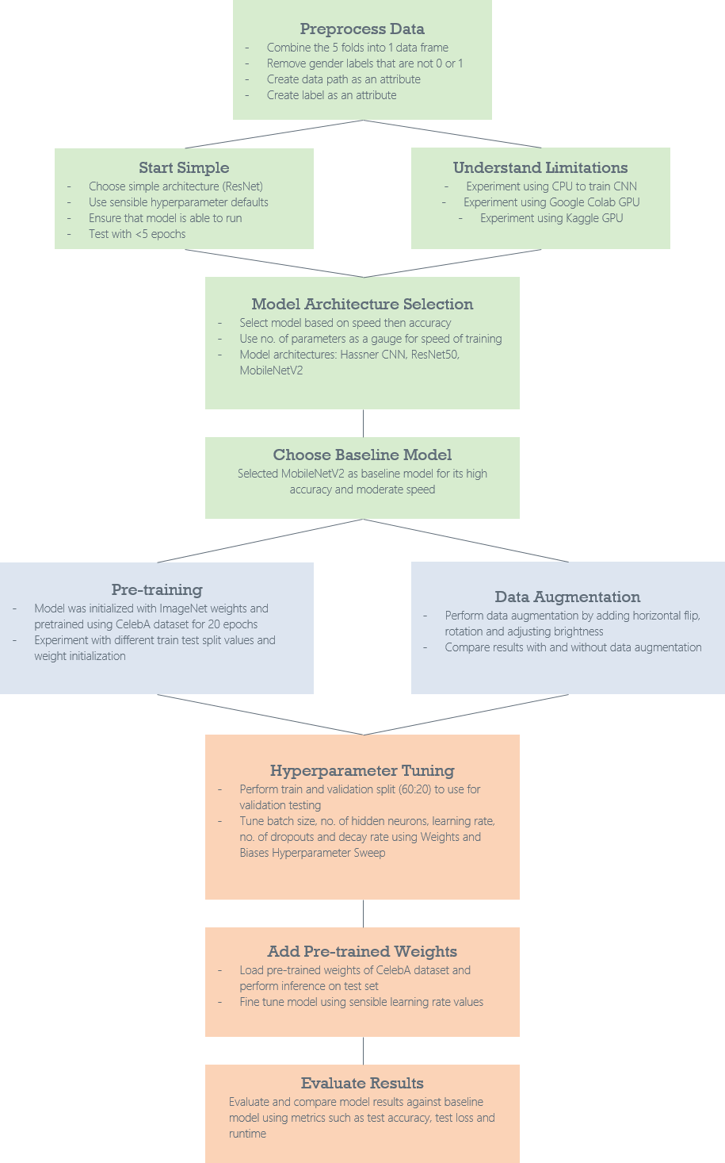

# Data Exploration

## CelebA

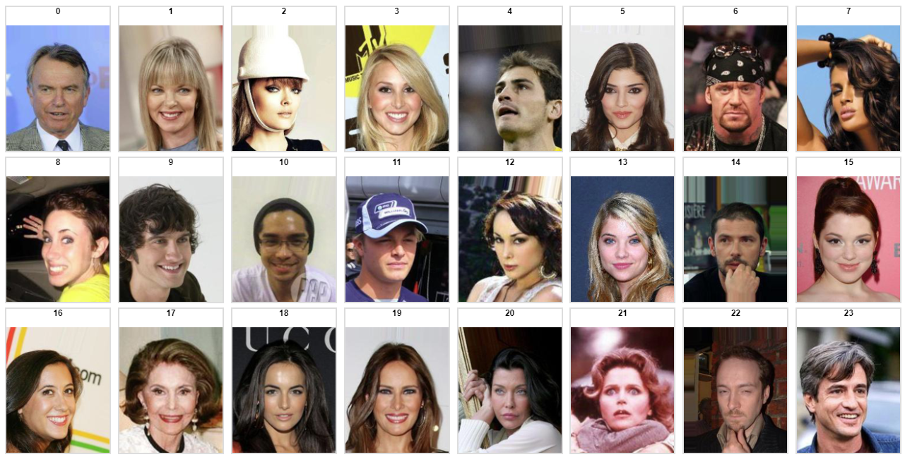

*Figure 1: Images in CelebA dataset*

### Dataset Description

CelebFaces Attributes Dataset (CelebA) is a large-scale face attributes dataset with more than 200K celebrity images, each with 40 attribute annotations. The images in this dataset cover large pose variations and background clutter. CelebA has large diversities, large quantities, and rich annotations, including:

* 10,177 number of identities,
* 202,599 number of face images, and
* 5 landmark locations, 40 binary attributes annotations per image.

The dataset can be employed as the training and test sets for the following computer vision tasks: face attribute recognition, face detection, landmark (or facial part) localization, and face editing & synthesis.

## Adience

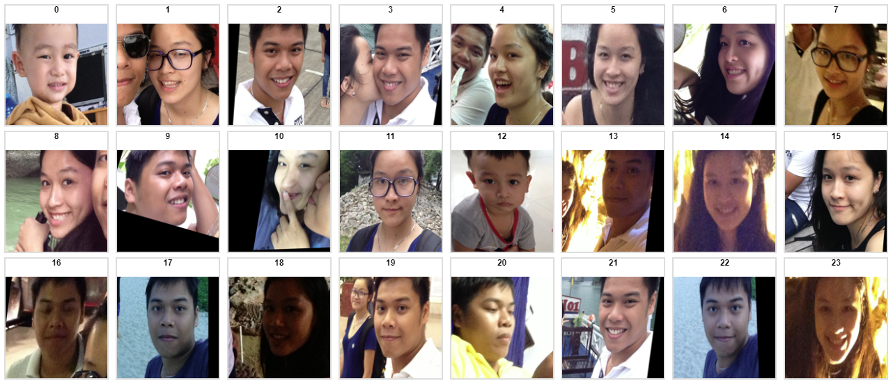

*Figure 2: Aligned Images in Adience Dataset*

### Dataset Description

The Adience set consists of images automatically uploaded to Flickr from smart-phone devices. These images were uploaded without prior manual filtering, as is typically the case on media webpages, viewing conditions in these images are highly unconstrained, reflecting many of the real-world challenges of faces appearing in Internet images. Adience images therefore capture extreme variations in head pose, lightning conditions quality, and more. The breakdown of the dataset is as follows:

* 26580 images,
* 2284 subjects
* 8 Age Groups (0-2, 4-6, 8-13, 15-20, 25-32, 38-43, 48-53, 60-)
* Aligned or Original

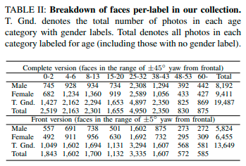

*Figure 3: Age and Gender Estimation of Unfiltered Faces [1]*

## Choice of Dataset

There are 2 datasets made available for the Adience image dataset, original or aligned. The aligned dataset was selected in this project because it consists of photos that have been preprocessed using a frontalization method which helps to substantially boost the performance of face recognition systems. [2]

## Changes to the Dataset

Due to the author’s corrections of the gender labels, the size of the dataset has been reduced from 26580 to 13560. [3] With data preprocessing, the genders not belonging to ‘f’ or ‘m’ are removed and that leaves us with 12194 images. Figure 4 as shown below is the final number of images used for gender classification.

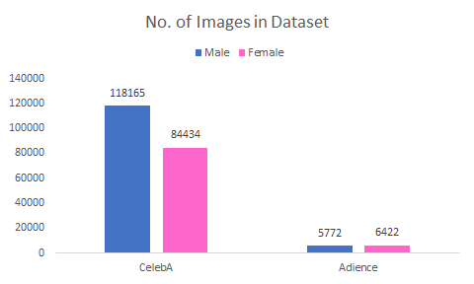

*Figure 4: No. of images in each dataset (Adience & CelebA)*

# Data Preprocessing

We selected the keras .flow_from_dataframe() method in combination with ImageDataGenerator to load the Adience and CelebA dataset. This is because the .txt files are linked to the image location in unlabelled folders. Before loading the dataframes, the .txt files need to be preprocessed to remove irrelevant rows and columns.

## Adience

There are a total of 5 .txt files labeled as fold_frontal_n.txt. We first transform the gender column for values ‘f’ to 0 and ‘m’ to 1. As there are a number of images that are not ‘m’ or ‘f’, they are removed from the dataset. The image directory is then created as a separate column (datadir) using user_id and original_image. These two attributes are then placed in a dataframe. After preprocessing the dataset, the dataset size is reduced from 13560 to 12194.

## CelebA

Similarly for the CelebA dataset, we create 2 columns (image directory and gender). The original dataset consists of 202599 images with more than 40 different attributes. The Male attribute represents the gender of the individual in the image. -1 represents female while 1 represents male. We replace -1 with 0 in the Male attribute. The image directory is then created as a separate column (datadir). These two columns are then placed in a dataframe.

# Modelling

Weights and Biases is a developer tool used to track, compare and visualize ML experiments. All the experiments that have been carried out in this project were recorded on Weights and Biases. The links to the table of results can be found in the Appendix section.

The process of modelling can be broken down into 7 parts.

1. Starting Simple
2. Understanding Limitations
3. Selection of Model Architecture
4. Data Augmentation
5. Hyperparameter Tuning
6. Pre-Training
7. Early Stopping

## Starting Simple

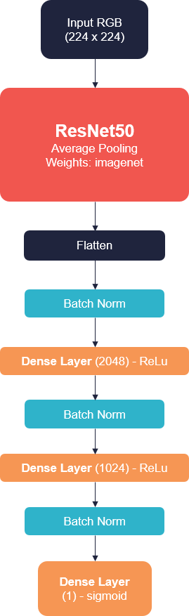

*Figure 5: First Model*

Training CNN models requires an extensive amount of time. The first step we took was to select a simple architecture such as ResNet50 to experiment on. The main goal is to ensure that the model is able to run smoothly without bugs. Sensible hyperparameter defaults were used. For example, we used imagenet weights as a base for ResNet50 and set the learning rate to 1e-3. No regularization was added. A batch size of 128 was selected. 2 fully connected layers of 2048 and 1024 neurons were added to progressively reduce the number of features as it reaches the base of the model.

## 

## Understanding Limitations

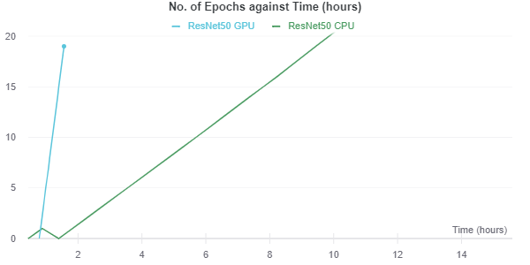

*Figure 6: No. of Epochs against Time (hours)*

|  |  |
| --- | --- |
| **Processor** | **Runtime per epoch** |
| Intel(R) Core i7-7500U CPU @2.70GHz, 8GB RAM | 26 mins 47 secs |
| Google Colab GPU Nvidia K80 0.82 GHz, 12GB RAM | 7 mins 8 secs |

We also faced an issue of training the datasets. Training the Adience dataset using CPU takes about 26 minutes per epoch which is not practical. We decided to use Google Colab GPU as it is free and is able to train the data at a faster rate. The training time was reduced to about 7 minutes per epoch. The Kaggle GPU was also used as it does not require the user to upload the image data to a set directory. That saves us the hassle of uploading more than 200,000 images in the CelebA dataset to the cloud.

Link to runs: <https://wandb.ai/todayisagreatday/NN_Project_Test_Runs/>

File: 3. Modelling/First Model -> resnet.py

# 

# Selecting Model Architecture

## Hassner CNN

Hassner CNN was the original CNN created for age and gender classification on the Adience dataset. [4]

It has an architecture that is relatively simple compared to nowadays state-of-the-art CNNs. It is made up of 3 convolutional layers, followed by 2 fully-connected layers, all with ReLU activation except for the last layer which uses softmax. Additional, max pooling is done after each convolutional layer, and dropout is done for both fully-connected layers. Unlike in modern CNNs, Hassner CNN uses local response normalisation instead of batch normalisation after the first two convolutional layers.

It achieved decent results on the Adience dataset, though it is not possible to tell how it compares to other models on the same dataset since it is first to be used on this dataset.

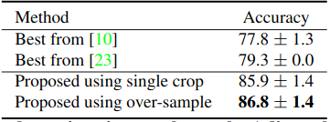

*Figure 7: Hassner CNN’s performance for gender estimation on the Adience dataset*

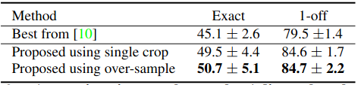

*Figure 8: Hassner CNN’s performance for age estimation on the Adience dataset*

For our implementation of Hassner CNN, although we try to be faithful to the original design, we have made some practical changes. In the original model, the images are resized to a height and width of 256x256, before being cropped into 227x227 as input into the model. In our implementation, we used an input size of 224x224 to be consistent with other models that we were considering. The smaller input meant a reduced amount of parameters (which is still a whopping 115,023,873 parameters), at the expense of accuracy. Furthermore, the original model uses softmax for activation in the output layer, since it needs to perform classification of different age groups in addition to gender classification. For this project, the objective is to classify genders only (i.e. binary classification), so we used sigmoid which is sufficient.

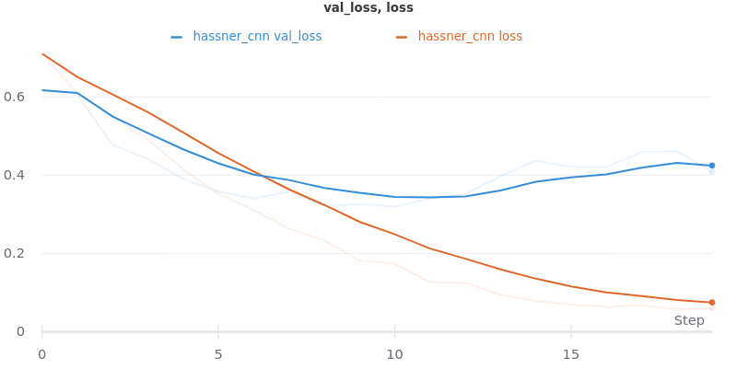

*Figure 9: validation and training loss for Hassner CNN, for gender classification on Adience dataset*

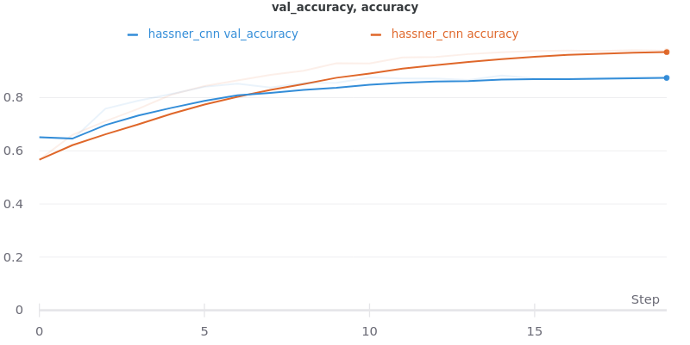

*Figure 10: validation and training accuracy for Hassner CNN, for gender classification on Adience dataset*

Upon evaluation of the model, we found that it performed well on the Adience dataset, with a validation accuracy of 0.8766.

Link to runs: <https://wandb.ai/burntice/cz4042/runs/nml0vw6q?workspace=user-burntice>

Notebook: ‘3. Modelling/Model Evaluation/hassner_cnn.ipynb’

Saved weights: ‘5. Saved Weights/Model Evaluation/hassner_cnn_eval.h5’

## ResNet50

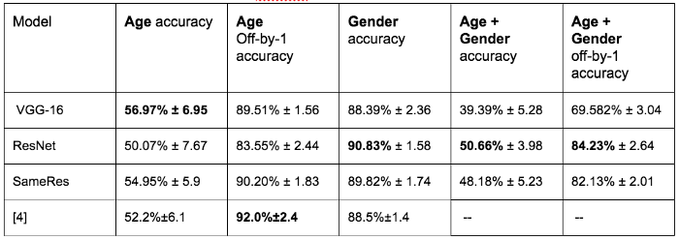

*Figure 11: Gender Accuracy based on a 5-Fold Cross Validation by Andrey Karapetov*

The ResNet model was selected as a possible architecture for image classification as it has won the 1st place on the ILSVRC 2015 classification task. [5] Additionally, it has over 60,000 Google citations and has been utilised by the creator of the Adience dataset (Andrey Karapetov). It has achieved a test score of 90.8% ± 1.58 when a 5-fold cross validation is done on the Adience data. [6]

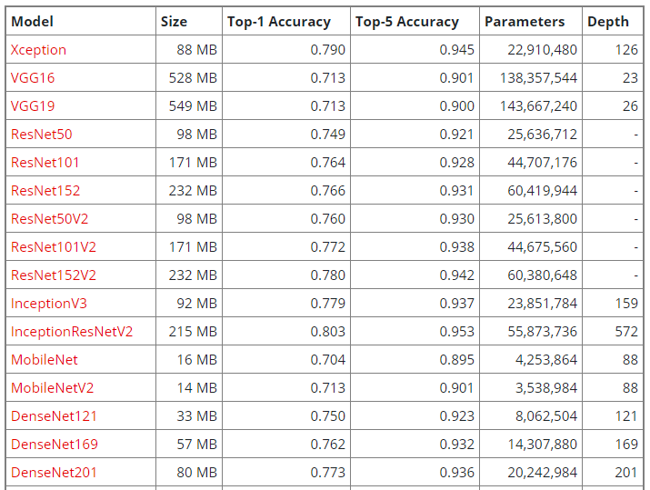

*Figure 12: State-of-the-Art deep learning models available in keras*

The above figure shows the list of state-of-the-art models benchmarked on the ImageNet dataset. The top-1 and top-5 accuracy refers to the model’s performance on the ImageNet validation dataset. Considering the number of parameters, we decided to select ResNet50 as a possible option as it has the lowest number of parameters (25,636,712) among the ResNet models. Using an architecture with a lower number of parameters will reduce the overall runtime during training.

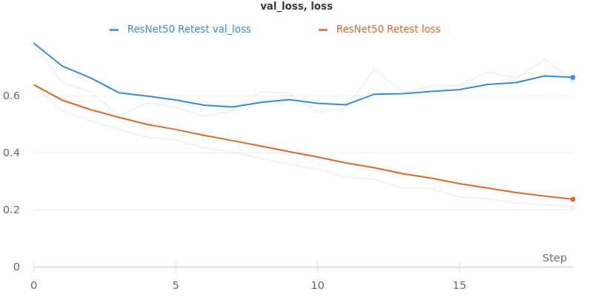

*Figure 13: validation and training loss for ResNet50, for gender classification on Adience dataset*

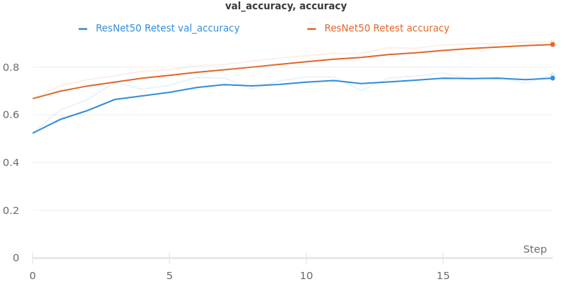

*Figure 14: validation and training accuracy for ResNet50, for gender classification on Adience dataset*

Upon evaluation of the model, we found that the performance was decent, with a test accuracy of 0.7688.

Link to runs: <https://wandb.ai/todayisagreatday/NN_Project_Test_Runs/?workspace=user-todayisagreatday>

Notebook: ‘3. Modelling/Model Evaluation/ResNet50.ipynb’

## MobileNetV2

Although ResNet is a tremendous improvement over Hassner CNN, neural networks have come a long way since then. The models in the MobileNet family are supposed to be lightweight and fast (when performing inference), while not compromising too much on accuracy. We picked MobileNetV2 instead of MobileNetV3 for evaluation since its model (with pre-trained ImageNet weights) is available on Tensorflow.

MobileNetV2 has 3 features that allowed it to beat other state-of-the-art of its time.

The first feature is depth-wise separable convolutions. Instead of using the standard convolution, MobileNetV2 splits the operation into 2 parts: a depthwise convolution, in which it applies a single convolution filter per input channel, followed by a pointwise convolution (1x1 convolution). Doing so allows it to perform convolutions at a lower computational cost while still working as well.

The second feature is linear bottlenecks. Due to the depth-wise separable convolutions, there is dimensionality reduction going on, which is more heavily affected by non-linearities like ReLU (since values less than 0 are lost). To deal with this problem, linear activation instead of non-linear activation is used at the narrow parts of the network.

The third feature is inverted residuals. These serve the same purpose as the residual connections in ResNet, in facilitating the backpropagation of gradients, while being more memory efficient than the traditional residual connection.

These 3 features are combined to form the bottleneck residual block, which is the mainstay of MobileNetV2. There are 19 of such layers before an input convolutional layer and the output convolutional layers in MobileNetV2’s architecture.

MobileNetV2’s design led to its impressive results in image classification, object detection and image segmentation, obtaining greater or equal results than its counterparts while occupying less space and requiring less time to run. [7]

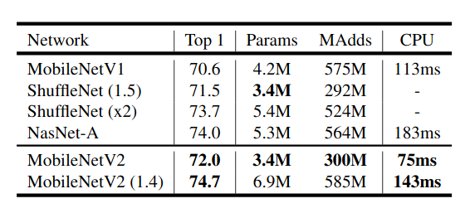

*Figure 15: MobileNetV2’s performance for image classification on ImageNet dataset*

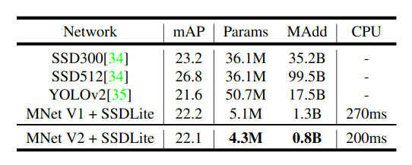

*Figure 16: MobileNetV2’s performance for object detection on COCO dataset*

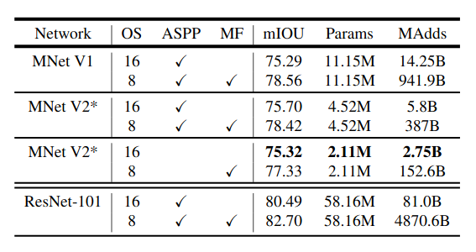

*Figure 17: MobileNetV2’s performance for image segmentation on Pascal VOC 2012 dataset*

For our own evaluation of MobileNetV2, we found that it has 2,264,640 parameters, which is less than that of Hassner CNN and ResNet. In addition, it yielded a validation accuracy of 0.8852 on the Adience dataset without a prior tuning.

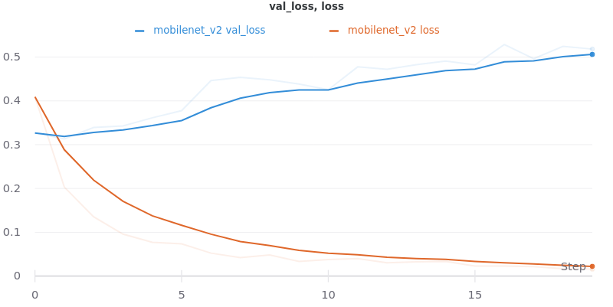

*Figure 18: validation and training loss for MobileNetV2, for gender classification on Adience dataset*

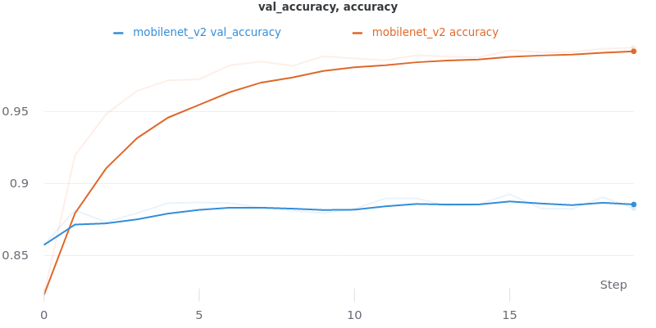

*Figure 19: validation and training accuracy for MobileNetV2, for gender classification on Adience dataset*

Link to runs: <https://wandb.ai/burntice/cz4042/runs/3n5txt0r?workspace=user-burntice>

Notebook: ‘3. Modelling/Model Evaluation/mobilenetv2.ipynb’

Saved weights: ‘5. Saved Weights/Model Evaluation/mobilenetv2_eval.h5’

## Comparison Of Model Architectures

The Hassner CNN is eliminated as a viable architecture as it simply has too many parameters to train on. This greatly increases the time needed to train the network and would make the tuning process difficult. This leaves the ResNet50 and the MobileNetV2 architecture for comparison. Aside from importing the base model from keras, the parameters used for the fully connected layers for both MobileNetV2 and ResNet50 are standardized to have the same values. The number of fully connected layers is increased from 2 to 3 and the number of neurons were changed to 1024>512>256 to reflect a progressive downsizing of the number of features.

These are the parameters used:

* Epochs: 20
* Learning Rate: 1e-3
* Batch Size: 64
* Optimizer: Adam
* Activation Function for hidden layers: ReLu
* Number of Neurons in Fully Connected Layer 1: 1024
* Number of Neurons in Fully Connected Layer 2: 512
* Number of Neurons in Fully Connected Layer 3: 256

|  |  |  |  |  |
| --- | --- | --- | --- | --- |
| **Model Name** | **Test Loss** | **Test Accuracy** | **Training Time** | **Test Time** |
| Hassner CNN | 0.4080 | 0.8766 | 1h 41m 9s | 971ms |
| ResNet50 | 0.6513 | 0.7688 | 1h 59m 11s | 17s |
| MobileNetV2 | 0.5182 | 0.8827 | 49m 1s | 707ms |

The table above shows the comparison results for the evaluated model architectures. As the performance of MobileNetV2 is better in terms of accuracy and runtime (both during training and inference), we decided to use MobileNetV2 as our base model architecture.

Notebook: hassner_cnn.ipynb, ResNet50.ipynb, mobilenetv2.ipynb

Link to runs: <https://wandb.ai/burntice/cz4042?workspace=user->

# 

# Data Augmentation

In data augmentation, our objective is to create more data from our existing dataset. This extra data will train the model for new exceptions. For example, our dataset may contain a few categories and one of the category might be taken by the same photographer. This photographer might tend to take photos of the object facing a specific direction for instance with the object facing the right. The model will then tend to associate photos with objects facing the right to be of that category. Data augmentation will change some of the image properties of that photo which will provide the model with augmented images. Below we shall explore some of the augmented techniques that we used for our image recognition model.

## Sample image from dataset

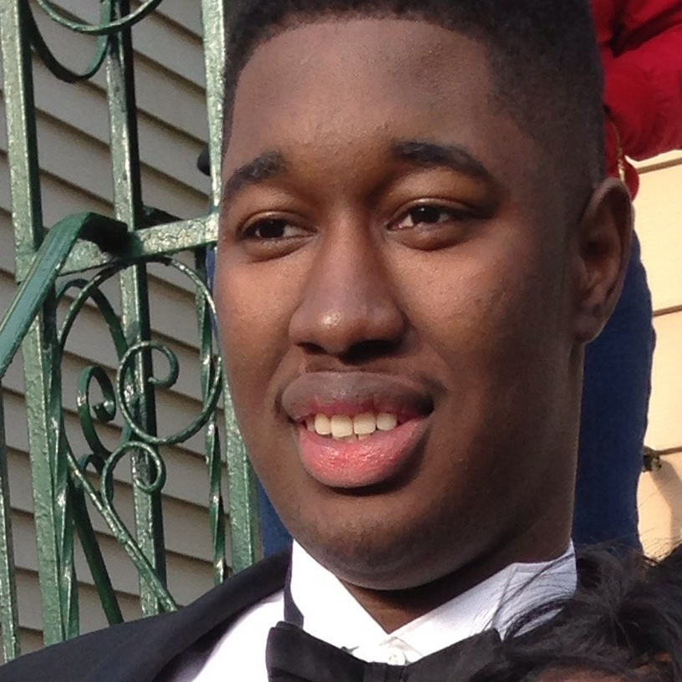

*Figure 20: sample image from dataset*

The above picture shows a sample from our training data. The dataset obtained is an aligned version of the original dataset. The author of this data has done some pre-processing to crop the images and align the faces to the middle of the frame. Therefore we will not be using shifting augmentation in our image preprocessing step.

## Horizontal Flip

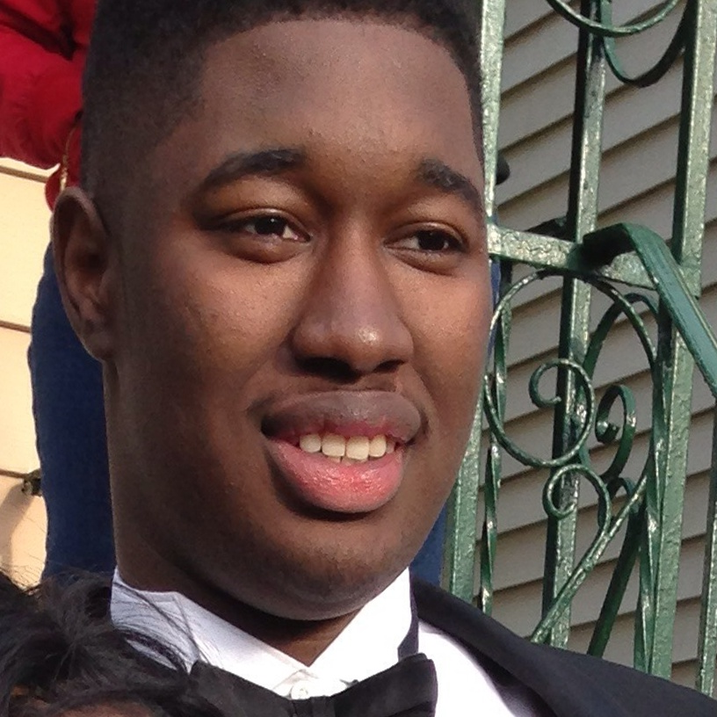

*Figure 21: Flipping the sample image horizontally*

In horizontal flipping, we changed the direction of the image in the horizontal direction. Comparing the above image with the one in the sample, we observed that the person is facing an opposite direction.

## Image Rotation



*Figure 22: Rotating the image 90 degree*

We will also be introducing rotation into our data augmentation. In the rotation, we will randomly sample images and rotate them between the angle of 0 to 90 degree in both the clockwise and anticlockwise direction.

## Adjusting Brightness

****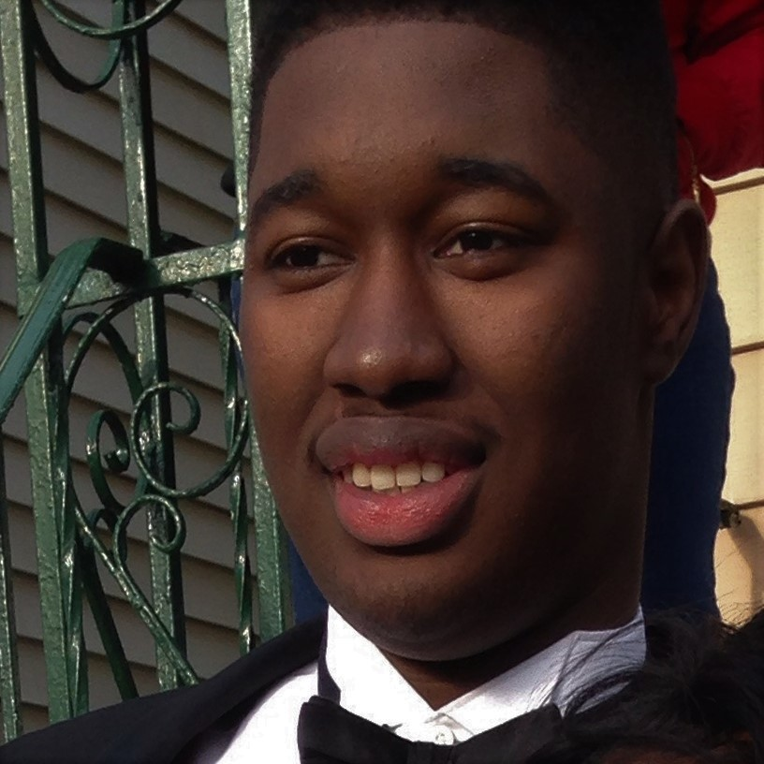

*Figure 23: Decreasing the brightness of the image (Left - Original)*

The last data augmentation is adjusting the brightness of certain images. A value of -0.5 to 1.5 with 1 being the original image brightness and a value greater than 1 making it brighter and less than 1 making it darker.

## Results

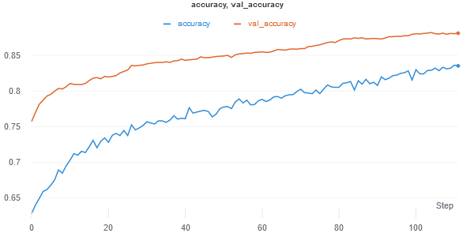

*Figure 24: Data Augmentation Accuracy*

After applying data augmentation, we achieved a max val accuracy of 0.88 after about 110 epochs. This is less than just training the dataset without augmentation that achieves an accuracy of over 0.9 accuracy. The reason for better accuracy without data augmentation could be due to preprocessing of the dataset by the author. While augmentation might not work as well for this project, it will tend to work better for images that have not been altered before.

**Hyperparameters used:**

* Epochs: 50
* Learning Rate: 1e-5
* Batch Size: 128
* Optimizer: Adam
* Activation Function for hidden layers: ReLu
* Number of Neurons in Fully Connected Layer 1: 1024
* Number of Neurons in Fully Connected Layer 2: 512
* Number of Neurons in Fully Connected Layer 3: 512

Comparison of with and without data augmentation

|  |  |  |  |  |
| --- | --- | --- | --- | --- |
| **Data Augmentation** | **Runtime (at 50 epochs)** | **Test Loss** | **Test Accuracy** | **No. of epochs** |
| Yes | 5h 24m | 0.3561 | 0.8491 | 50 |
| No | 4h 8m 25s | 0.2764 | 0.9 | 50 |

Files:

3. Modelling/MNV2 Experiments -> mobilenetv2_celeba_v5.ipynb

5. Saved Weights/CelebA -> model_celeba_no_val.h5

6. Data Augmentation -> mobilenetv2_celeba_v5_data_aug.ipynb

# Hyperparameter Tuning

For hyperparameter tuning, we split it up into 4 runs to reduce the number of combinations to search through. The assumption made here is that the hyperparameters to be tuned across different runs are independent of each other.

We searched for the optimal hyperparameters using grid search, with the help of the sweep function from Weights and Biases. For each combination of hyperparameters, the model is trained for 20 epochs.

## Optimal Batch Size, Neurons and Learning Rate

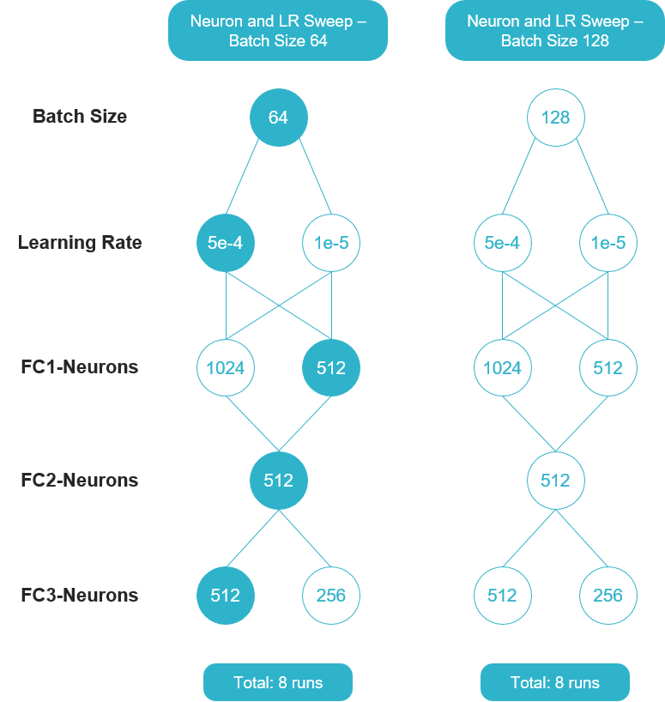

*Figure 25: 2 Sweeps split by batch size (Optimal parameters highlighted)*

For the first run, we performed a sweep for learning rate ∈ { 5e-4, 1e-5 }, number of neurons in FC1 ∈ { 1024, 512 } and number of neurons in FC3 ∈ { 512, 256 }, for a batch size of 128. The second run is similar to the first run, except that the batch size is set to 64. These two runs were done in parallel (on two Google Colaboratory notebooks) to speed up the tuning process. Note that the number of neurons in FC2 is set to 512 instead of being swept for. We reasoned that since the earlier layers in fully-connected layers tend to have more neurons, and the later layers tend to have less neurons, then the middle layers should have an in-between number of neurons (i.e. num_fc1_neurons ≥ num_fc2_neurons ≥ num_fc3_neurons).

Results of the first two runs (optimal parameters and results are underlined)

|  |  |  |  |  |  |
| --- | --- | --- | --- | --- | --- |
| **batch size** | **learning rate** | **FC1 neurons** | **FC3 neurons** | **val loss** | **val accuracy** |
| 128 | 5e-4 | 1024 | 512 | 1.314906 | 0.788313 |
| 128 | 5e-4 | 1024 | 256 | 0.723441 | 0.788313 |
| 128 | 5e-4 | 512 | 512 | 1.790023 | 0.776524 |
| 128 | 5e-4 | 512 | 256 | 2.294764 | 0.496155 |
| 128 | 1e-5 | 1024 | 512 | 18.312383 | 0.863659 |
| 128 | 1e-5 | 1024 | 256 | 17.236421 | 0.869810 |
| 128 | 1e-5 | 512 | 512 | 14.455925 | 0.867760 |
| 128 | 1e-5 | 512 | 256 | 13.259344 | 0.856996 |
| 64 | 5e-4 | 1024 | 512 | 1.132274 | 0.707842 |
| 64 | 5e-4 | 1024 | 256 | 1.190108 | 0.837006 |
| 64 | 5e-4 | 512 | 512 | 0.273368 | 0.926704 |
| 64 | 5e-4 | 512 | 256 | 0.231337 | 0.922091 |
| 64 | 1e-5 | 1024 | 512 | 15.417082 | 0.893900 |
| 64 | 1e-5 | 1024 | 256 | 14.634536 | 0.876473 |
| 64 | 1e-5 | 512 | 512 | 12.519720 | 0.882624 |
| 64 | 1e-5 | 512 | 256 | 11.563533 | 0.870835 |

Notebooks: ‘7. Hyperparameter Tuning/hyperparams_tuning_batchn.ipynb’

Link to sweep: <https://wandb.ai/burntice/nn_project_tuning/sweeps/r4y8hd2a?workspace=user->

<https://wandb.ai/burntice/nn_project_tuning/sweeps/30jubtgn?workspace=user->

<https://wandb.ai/burntice/nn_project_tuning/sweeps/j0r78xbh?workspace=user->

## Optimal Decay Rate

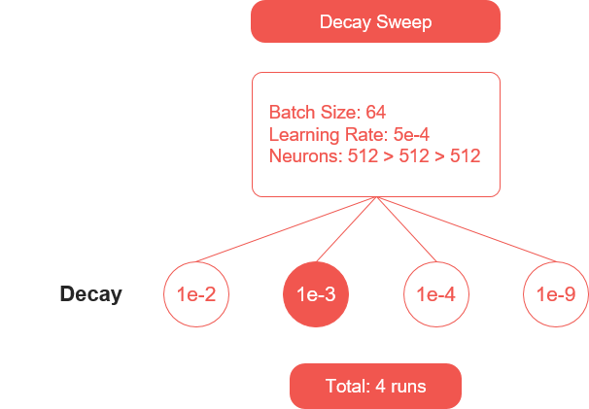

*Figure 26: Decay Sweep (optimal parameter highlighted)*

For the third run, the optimal hyperparameters based on the first two runs were used. In this run, we performed a sweep on weight decay ∈ { 1e-2, 1e-3, 1e-4, 1e-9 }.

Results of the third run (optimal parameters and results are underlined)

|  |  |  |
| --- | --- | --- |
| **weight decay** | **val loss** | **val accuracy** |
| 1e-9 | 0.017376 | 0.892875 |
| 1e-4 | 0.763034 | 0.893388 |
| 1e-3 | 0.208280 | 0.942080 |
| 1e-2 | 0.439983 | 0.908764 |

Link to sweep: <https://wandb.ai/burntice/nn_project_tuning/sweeps/rko63m53?workspace=user->

Notebooks: ‘7. Hyperparameter Tuning/hyperparams_tuning_L2.ipynb’,

‘7. Hyperparameter Tuning/hyperparams_tuning_L2 (Decay 1e-9).ipynb’

## Optimal No. of Dropouts

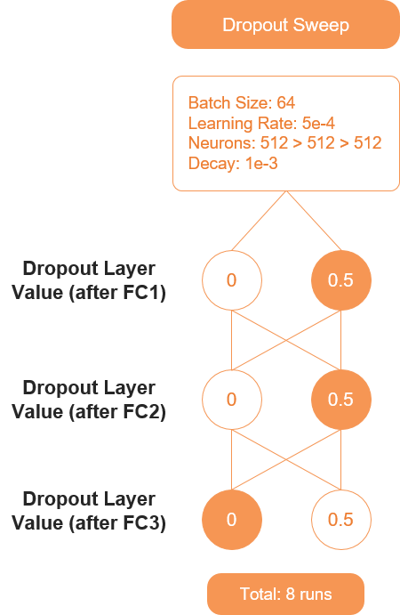

*Figure 27: Dropout Sweep (optimal parameters highlighted)*

For the fourth and last run, the optimal hyperparameters based on the first three runs were used. In this run, we performed a sweep on dropout rate for FC1 ∈ { 0, 0.5 }, dropout rate for FC2 ∈ { 0, 0.5 } and dropout rate for FC3 ∈ { 0, 0.5 }.

Results of the fourth run (optimal parameters and results are underlined)

|  |  |  |  |  |
| --- | --- | --- | --- | --- |
| **dropout rate 1** | **dropout rate 2** | **dropout rate 3** | **val loss** | **val accuracy** |
| 0.5 | 0.5 | 0.5 | 0.772137 | 0.859559 |
| 0.5 | 0.5 | 0 | 0.255795 | 0.950281 |
| 0.5 | 0 | 0.5 | 2.447204 | 0.611993 |
| 0.5 | 0 | 0 | 1.893447 | 0.836494 |
| 0 | 0.5 | 0.5 | 0.924545 | 0.862634 |
| 0 | 0.5 | 0 | 0.462397 | 0.932342 |
| 0 | 0 | 0.5 | 0.533465 | 0.888262 |
| 0 | 0 | 0 | 0.496854 | 0.919528 |

Link to sweep: <https://wandb.ai/burntice/nn_project_tuning/sweeps/001rfn8c?workspace=user->

Notebook: ‘7. Hyperparameter Tuning/hyperparams_tuning_dropout.ipynb’

# Pre-training

This section will be divided into 2 parts. Before tuning and after tuning. Before tuning refers to experiments that were carried out without hyperparameter tuning. After tuning refers to experiments that were carried out after hyperparameter tuning of the model.

A pre-trained model is a model that was trained on a large benchmark dataset to solve a problem similar to the one that we are intending to solve. Pre-training a model that closely resembles the training data helps to greatly boost the accuracy of the model. In this specific example, we use the CelebA dataset as it is a large dataset of over 200,000 images and is similar to the Adience dataset.

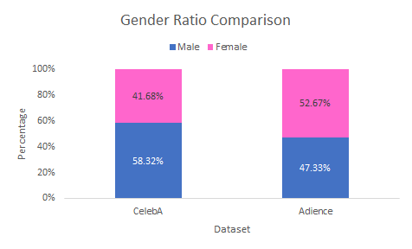

*Figure 28: Class balance between Adience and CelebA*

As we can observe from Figure 28, the classes are relatively similar to each other in terms of the gender ratio. This makes the CelebA dataset suitable for solving the task of gender classification like in Adience.

## 

## Experiments Before Tuning

**Fixed Hyperparameters:**

* Epochs: 20
* Batch Size: 128
* Optimizer: Adam
* Activation Function for hidden layers: ReLu
* Number of Neurons in Fully Connected Layer 1: 1024
* Number of Neurons in Fully Connected Layer 2: 512
* Number of Neurons in Fully Connected Layer 3: 512

**Hyperparameters tested**

* Learning Rate: 1e-3 or 3e-4
* Target Image Size: (112,112) or (224, 224)
* Train Test Split: 90:10 or 80:20
* Weights: None or ImageNet

Several experiments were carried out to determine the best way of carrying out pre-training.

|  |  |  |  |  |
| --- | --- | --- | --- | --- |
| **Model** | **Weights** | **Target Image size** | **CelebA Test Accuracy** | **Adience Test Accuracy** |
| CelebA Resized ZW | None | 112 x 112 | 0.972 | 0.6052 |
| CelebA Resized | Imagenet | 112 x 112 | 0.9794 | 0.6371 |
| CelebA | Imagenet | 224 x 224 | 0.9669 | 0.7868 |
| Baseline Adience Model | Imagenet | 224 x 224 | - | 0.8827 |

3 models using the MobileNetV2 architecture were trained with 20 epochs and tested on the Adience dataset. The mobilenetV2 base model is frozen leaving only the fully connected layers to be trainable. Both datasets have a train test split ratio of 80:20. As we can observe from the table above, the test accuracy is very much lower as compared to the baseline model which has a test accuracy of 0.8827. Hence, we would need to perform fine-tuning on the model.

Link to runs: <https://wandb.ai/todayisagreatday/CelebA%20Runs?workspace=user->

Files:

4. CelebA/Training -> celeb-a-pretrain_Vn.ipynb

3. Modelling/MNV2 Experiments -> mobilenetv2_celeba_vn.ipynb

Weights:

5. Saved Weights/CelebA -> model_celeba, model_celeba_resized.h5, model_celeba_resized_zerow.h5

**Fine-Tuning**



*Figure 29: Workflow for fine-tuning*

Following the keras documentation guide, the base model (MobileNetV2) was unfreezed and a low learning rate of 1e-5 was used. [8] This tremendously improved the performance of the model, increasing the test accuracy to 0.9147. The accuracy and loss curves over 50 epochs can be seen below.

|  |  |  |  |
| --- | --- | --- | --- |
| Model | Learning rate | CelebA Test Accuracy | Adience Test Accuracy |
| CelebA | 1e-3 | 0.9669 | 0.7868 |
| CelebA-LR | 1e-5 | 0.9669 | 0.9147 |

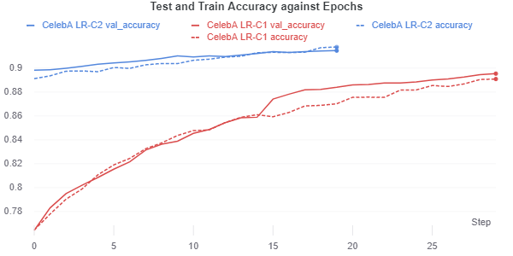

*Figure 30: Test and Train Accuracy against epochs (blue line is a continuation of red line)*

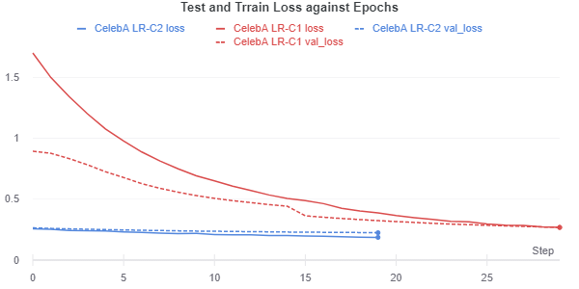

*Figure 31: Test and Train Loss against epochs (blue line is a continuation of red line)*

Using the Weights and Biases resume function, we are able to let the model run for an additional 20 more epochs after the cell has stopped. This explains why the accuracy and loss curve is split into 2 (red first then blue). As we can observe from Figure 30 and 31, there is minimal overfitting as the test and train curves are very close to each other. While 91.47% is a great score, the model has not been tuned yet.

**Hyperparameters for Adience Testing:**

* Epochs: 50
* Batch Size: 128
* Optimizer: Adam
* Learning Rate: 1e-5
* Target Image Size: (224, 224)
* Train Test Split: 80:20
* Weights: CelebA pretrained
* Activation Function for hidden layers: ReLu
* Number of Neurons in Fully Connected Layer 1: 1024
* Number of Neurons in Fully Connected Layer 2: 512
* Number of Neurons in Fully Connected Layer 3: 512

Link to runs: <https://wandb.ai/todayisagreatday/transfer_learning_mnv2?workspace=user-todayisagreatday>

Notebooks:

3. Modeling/MNV2 Experiments -> mobilenetv2_celeba_vn.ipynb

Weights:

5. Saved Weights/CelebA -> model_celeba, model_celeba_resized.h5, model_celeba_resized_zerow.h5

## Experiments After Tuning

### Without pretraining

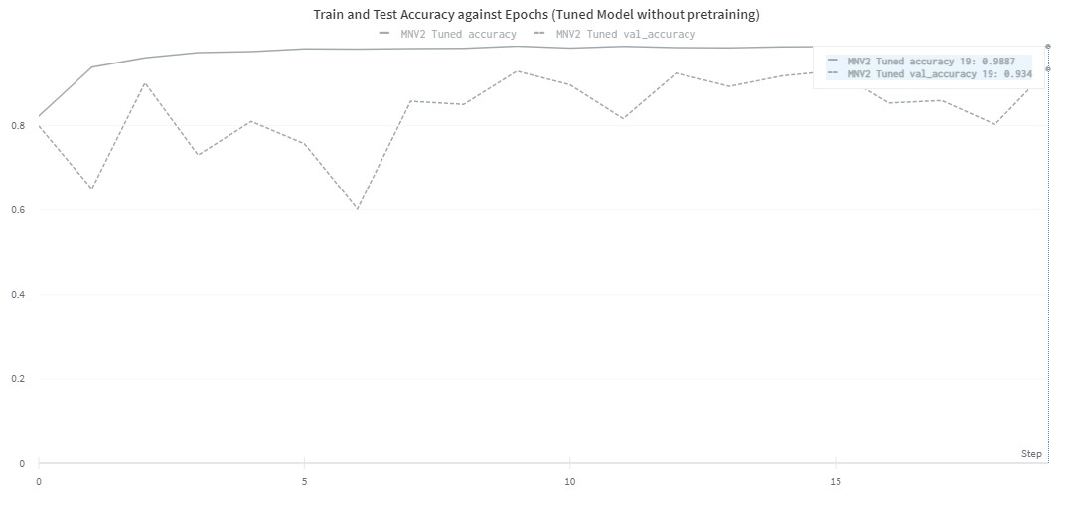

*Figure 32: Train and test accuracy against epochs (tuned model without pre training)*

Using the optimal parameters we obtained from hyperparameter tuning, we ran the model for 20 epochs and achieved a score of 0.934. Despite the great result, the instability in the model indicates that the learning rate is too high.

**Hyperparameters for Adience Testing:**

* Epochs: 20
* Batch Size: 64
* Optimizer: Adam
* Learning Rate: 5e-4
* Target Image Size: (224, 224)
* Train Test Split: 80:20
* Weights: CelebA pretrained
* Activation Function for hidden layers: ReLu
* Number of Neurons in Fully Connected Layer 1: 512
* Number of Neurons in Fully Connected Layer 2: 512
* Number of Neurons in Fully Connected Layer 3: 512

### 

### After Pretraining

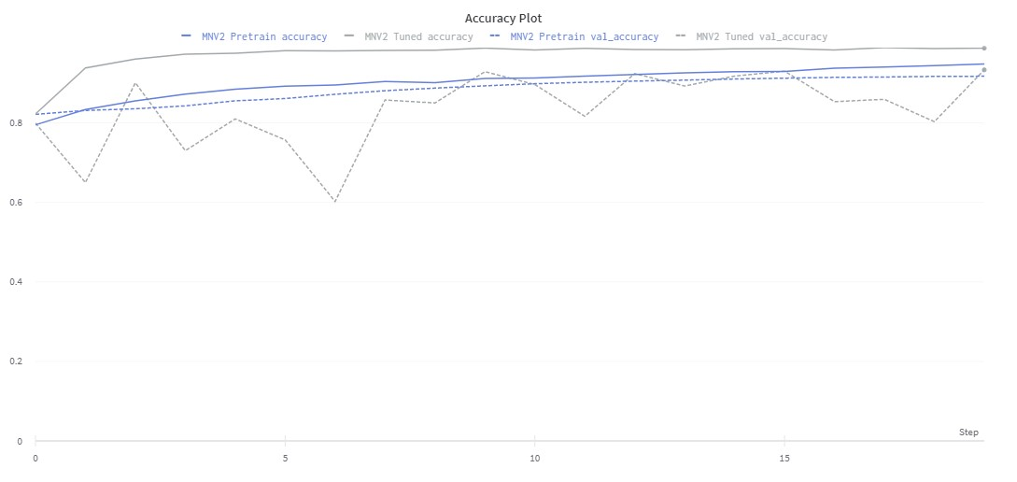

*Figure 33: Comparison between CelebA and imagenet weights*

MNV2 Pretrain (blue) represents the model with CelebA pretrained weights while MNV2 Tuned (grey) represents the model with Imagenet weights. By lowering the learning rate to 1e-5 and adding the pretrained CelebA weights, we are able to achieve a more consistent result as the number of epochs increases.

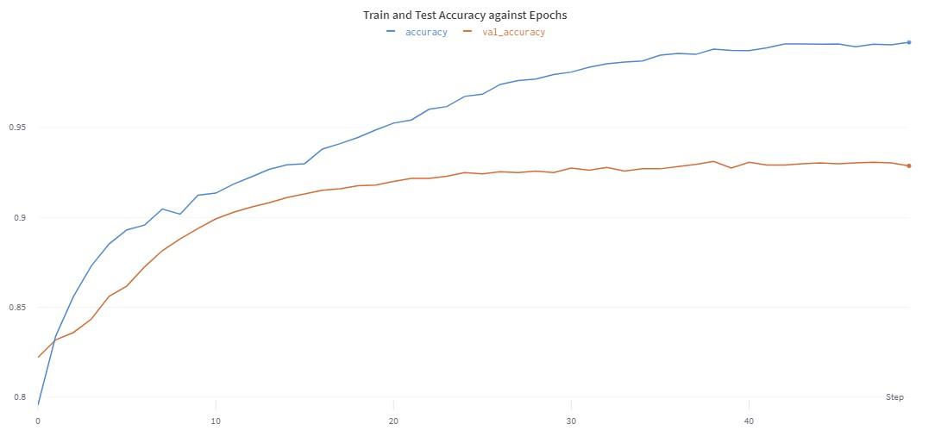

*Figure 34: Train and Test accuracy against epochs after pre training and tuning*

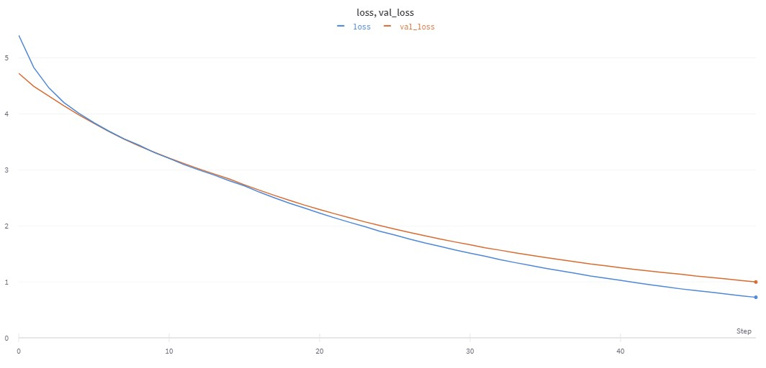

*Figure 35: Train and Test loss against epochs after pre training and tuning*

After running the model (MNV2 Pretrain) for a total of 50 epochs, we are able to reach a test accuracy of 0.9287. The model converges at a faster rate when comparing the model without tuning and the model with tuned parameters. There is also overfitting present as the number of epochs increases. The overall comparison will be evaluated in the next section.

**Hyperparameters for CelebA Pretrain:**

* Epochs: 20
* Batch Size: 128
* Optimizer: Adam
* Learning Rate: 3e-4
* Target Image Size: (224, 224)
* Train Test Split: 90:10
* Weights: Imagenet
* Activation Function for hidden layers: ReLu
* Number of Neurons in Fully Connected Layer 1: 512
* Number of Neurons in Fully Connected Layer 2: 512
* Number of Neurons in Fully Connected Layer 3: 512

**Hyperparameters for Adience Testing:**

* Epochs: 50
* Batch Size: 64
* Optimizer: Adam
* Learning Rate: 1e-5
* Target Image Size: (224, 224)
* Train Test Split: 80:20
* Weights: CelebA pretrained
* Activation Function for hidden layers: ReLu
* Number of Neurons in Fully Connected Layer 1: 512
* Number of Neurons in Fully Connected Layer 2: 512
* Number of Neurons in Fully Connected Layer 3: 512

Link to runs: <https://wandb.ai/burntice/nn_project_tuning?workspace=>

Files:

3. Modelling/MNV2 Experiments -> mobilenetv2_celeba_tune.ipynb, mobilenetv2_tuned.ipynb

4. CelebA/Training -> celeb-a-pretrain_tune.ipynb

Weights:

5. Saved Weights/CelebA -> model_celeba_tune.h5

# Evaluation of Results

|  |  |  |  |
| --- | --- | --- | --- |
| **Model** | **Test Accuracy** | **Test Loss** | **Epochs** |
| Baseline MNV2 | 0.8827 | 0.5182 | 20 |
| MNV2 Pretrained | 0.9147 | 0.1865 | 50 |
| MNV2 Tuned | 0.934 | 0.06276 | 50 |
| MNV2 Tuned + Pretrained | 0.9287 | 0.7237 | 50 |

The above table shows the improvement of results from the baseline model to the final tuned and pretrained model. After tuning and pre training, the test accuracy has increased by 4.6%.

# Future Considerations

To further improve and validate the results would require additional testing. Below are a few ways that can possibly improve the model’s performance

**Learning Rate Scheduler**

As the model is observed to be overfitting, by setting the learning rate to decrease over time, this would allow the model to speed up the training process at the beginning and obtain optimal weights as the number of epochs increases.

**Cross Validation**

In Hassner’s research paper, he conducted a 5-fold cross validation to ensure the validity of the results. Likewise, cross validation could be performed using the MobileNetV2 model to validate the results obtained.

# Conclusion

In this project, we performed gender classification of images using the Adience and CelebA dataset. The dataset directory text files were first preprocessed into dataframes. Next, we limited our selection of models to 3 different architectures (Hassner CNN, ResNet50, MobileNetV2). After testing the model architectures, we selected MobileNetV2 as our base model to use for classification due to its great accuracy and moderate speed. Following the selection of MobileNetV2, we experimented with augmenting the data, tuning the model as well as pre training the model with CelebA dataset. This gave us an overall test accuracy of 0.9287.

# Appendix

## CelebA Pre Training Results

<https://wandb.ai/todayisagreatday/CelebA%20Runs?workspace=user-todayisagreatday>

## Modelling Results

**Before Pre Training**

Model Comparison (ResNet, MobileNet V2 and Hassner CNN)

<https://wandb.ai/burntice/cz4042>

ResNet (Initial Testing)

<https://wandb.ai/todayisagreatday/NN_Project_Test_Runs/>

**After Pretraining**

MobileNetV2

<https://wandb.ai/todayisagreatday/transfer_learning_mnv2?workspace=user-todayisagreatday>

## Hyperparameter Tuning Results

<https://wandb.ai/burntice/nn_project_tuning?workspace=user-burntice>

# 

# Glossary

|  |  |
| --- | --- |
| **Term** | **Description** |
| MNV2 | MobileNetV2 |
| FC1/2/3 | Stands for the 1st, 2nd and 3rd **F**ully **C**onnected layers in the model after the flatten layer |
| Val loss | Validation loss |
| Val accuracy | Validation accuracy |
| CNN | Convolutional neural network |
| ReLU | Rectified linear unit |
| Training time | Time taken for a model to train on the training set |
| Test time | Time taken for a model to evaluate the test set, for 1 step |
| wandb | Weights and Biases. A developer tool for recording and visualizing ML experiments |
| Hyperparameter Sweep | Hyperparameter sweeps (unique to wandb) provide an organized and efficient way to conduct a battle royale of models and pick the most accurate model. They enable this by automatically searching through combinations of hyperparameter values (e.g. learning rate, batch size, number of hidden layers, optimizer type) to find the most optimal values. |

# 

# Bibliography

[1] E. Eidinger, R. Enbar and T. Hassner, "Age and Gender Estimation of Unfiltered Faces," in IEEE Transactions on Information Forensics and Security, vol. 9, no. 12, pp. 2170-2179, Dec. 2014, doi: 10.1109/TIFS.2014.2359646.

[2] T. Hassner, S. Harel, E. Paz and R. Enbar. Effective Face Frontalization in Unconstrained Images. IEEE Conf. on Computer Vision and Pattern Recognition (CVPR), Boston, 2015.

[3] T. Hassner, "Face Image Project - Data", Talhassner.github.io, 2014. [Online]. Available: https://talhassner.github.io/home/projects/Adience/Adience-data.html#agegender. [Accessed: 22- Nov- 2020].

[4] G. Levi and T. Hassner, Age and Gender Classification Using Convolutional Neural Networks. IEEE Workshop on Analysis and Modeling of Faces and Gestures (AMFG), at the IEEE Conf. on Computer Vision and Pattern Recognition (CVPR), Boston, 2015.

[5] K. He, X. Zhang, S. Ren and J. Sun, "Deep Residual Learning for Image Recognition", arXiv.org, 2015. [Online]. Available: https://arxiv.org/abs/1512.03385. [Accessed: 22- Nov- 2020].

[6] A. Karapetov, "Age and Gender Classification using Deep Neural Networks", Medium, 2018. [Online]. Available: https://medium.com/@andreykar_79244/age-and-gender-classification-using-deep-neural-networks-a8ded298a838. [Accessed: 22- Nov- 2020].

[7] M. Sandler, A. Howard, M. Zhu, A. Zhmoginov and L. Chen, "MobileNetV2: Inverted Residuals and Linear Bottlenecks", arXiv.org, 2018. [Online]. Available: https://arxiv.org/abs/1801.04381. [Accessed: 23- Nov- 2020].

[8] F. Chollet, "Keras documentation: Transfer learning & fine-tuning", Keras.io, 2020. [Online]. Available: https://keras.io/guides/transfer_learning/. [Accessed: 22- Nov- 2020].